Logistics N’ Funding

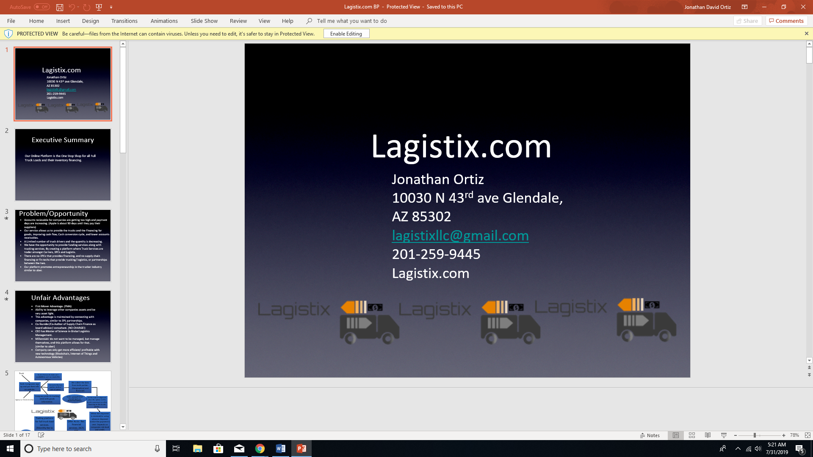

IST 659 Project

Jonathan Ortiz

**Project Summary:**

I am trying to start a trucking company under a new business model, instead of the traditional pay for my trucking service, I want to finance inventory that is on the truck, this can be an added benefit, but most likely our main source of income.

For this project I will be building a database with vendor - buyer relationships. The information in this database will be what trucking companies they use, or are under contract with them, the industry of the companies and main products the companies are known for. The result should be a database comprised of companies’ relationships between buyer and seller that may need a supply chain financing service. This project will be able to find those companies in need and whether their existing trucking service may be able to provide them these services, moreover, if there is enough profit margin in the industry or product to use these services.

**Stakeholder Description:**

The stakeholders of this project are:

Vendor Companies: They will be able to recognize if they can be using this financial service to increase cashflow.

Economists: Can use this database to look at the health of the

Tucking Companies: Can use this tool to find opportunities to provide funding for products in their trucks, this can help build relationships through providing transportation as a financial service.

Buying Companies: Buying companies can view how many days they are paying their vendors and how it is affecting their cashflow, which affect buyer vendor relationships.

Banks: Because of the new financing sources banks will be lending out more capital.

**ERD Model Changes**

VendorCompany (VendorID, VendorCompany, Days Receivable Outstanding)

BuyerCompany (BuyerID, BuyerName, Days Payable Outstanding)

Vender Buyer (VendorID, TruckerID, BuyerID, ItemID)

TruckingCompany (TruckingID,TruckingName Cash On Hand)

Products (ProductID)

**The Code**

--dropping all table that might exist error free. Entities that contain foreign keys must be first.

IF OBJECT_ID('dbo.VendorBuyer') IS NOT NULL

DROP TABLE dbo.VendorBuyer;

go

IF OBJECT_ID('dbo.VendorCompany') IS NOT NULL

DROP TABLE dbo.VendorCompany;

go

IF OBJECT_ID('dbo.BuyerCompany') IS NOT NULL

DROP TABLE dbo.BuyerCompany;

go

IF OBJECT_ID('dbo.Item') IS NOT NULL

DROP TABLE dbo.Item;

go

IF OBJECT_ID('dbo.TruckingCompany') IS NOT NULL

DROP TABLE dbo.TruckingCompany;

go

--Table for the vendor company

Create Table VendorCompany (

VendorID int primary key

, VendorName Varchar (20) not null

, DaysReceivableOutstanding Varchar (3) not null default '0'

)

Insert into VendorCompany (VendorID, VendorName, DaysReceivableOutstanding)

values ('472701', 'Hasbro', '74')

Insert into VendorCompany (VendorID, VendorName, DaysReceivableOutstanding)

values ('388652', 'Panasonic', '91')

Insert into VendorCompany (VendorID, VendorName, DaysReceivableOutstanding)

values ('205463', 'Bell PHarmaceutical', '77')

Insert into VendorCompany (VendorID, VendorName, DaysReceivableOutstanding)

values ('585672', 'Apple', '37')

Insert into VendorCompany (VendorID, VendorName, DaysReceivableOutstanding)

values ('444484', 'Black and Decker', '102')

Insert into VendorCompany (VendorID, VendorName, DaysReceivableOutstanding)

values ('734864', 'Champions', '27')

Insert into VendorCompany (VendorID, VendorName, DaysReceivableOutstanding)

values ('257915', 'Coca Cola', '6')

Insert into VendorCompany (VendorID, VendorName, DaysReceivableOutstanding)

values ('732578', 'Ford Group', '117')

Insert into VendorCompany (VendorID, VendorName, DaysReceivableOutstanding)

values ('221942', 'Energy Inc', '45')

Insert into VendorCompany (VendorID, VendorName, DaysReceivableOutstanding)

values ('452920', 'Google', '12')

Insert into VendorCompany (VendorID, VendorName, DaysReceivableOutstanding)

values ('237831', 'Hollywood Beauty', '59')

--Table for the Trucking Company

Create Table TruckingCompany (

TruckingID int primary key

, TruckingName Varchar (20) not null

, CashOnHand money not null default '0'

)

Insert into TruckingCompany (TruckingID, TruckingName, CashOnHand)

Values ('111', 'Saia', '1000000')

Insert into TruckingCompany (TruckingID, TruckingName, CashOnHand)

Values ('222', 'Walmart', '7000000000')

Insert into TruckingCompany (TruckingID, TruckingName, CashOnHand)

Values ('333', 'Swift', '82486000')

Insert into TruckingCompany (TruckingID, TruckingName, CashOnHand)

Values ('444', 'Kinght', '82486000')

Insert into TruckingCompany (TruckingID, TruckingName, CashOnHand)

Values ('555', 'FedEx', '2319000000')

-- Table for the buying company

Create Table BuyerCompany (

BuyerID int primary key

, BuyerName varchar(20) not null

, DaysPayableOutstanding varchar (3) not null default '0'

, Retailer varchar(1) not null

)

Insert into BuyerCompany ( BuyerID, BuyerName, DaysPayableOutstanding, Retailer)

Values ('001', 'Walmart', '64', '1')

Insert into BuyerCompany ( BuyerID, BuyerName, DaysPayableOutstanding, Retailer)

Values ('002', 'Jet', '64', '1')

--Table for the item

Create Table Item (

ItemNumber int primary key

, Nomen varchar(25) not null

, Cost money not null

, Price money not null

, Sortable varchar(1) not null

)

Insert into Item(ItemNumber, Nomen, Cost, Price, Sortable)

Values ('554744014', 'Hulk Hands', '16.92', '18.79', '1')

Insert into Item(ItemNumber, Nomen, Cost, Price, Sortable)

Values ('551660157', 'Bread Maker', '40', '49.99', '1')

Insert into Item(ItemNumber, Nomen, Cost, Price, Sortable)

Values ('551697871', 'Caffiene Pills', '2', '6.65', '1')

Insert into Item(ItemNumber, Nomen, Cost, Price, Sortable)

Values ('555825944', 'Ipad', '345', '799', '1')

Insert into Item(ItemNumber, Nomen, Cost, Price, Sortable)

Values ('552012599', 'Power Drill', '95', '159', '1')

Insert into Item(ItemNumber, Nomen, Cost, Price, Sortable)

Values ('553144451', 'Black V-neck', '1.15', '4.99', '1')

Insert into Item(ItemNumber, Nomen, Cost, Price, Sortable)

Values ('559732741', '12 Pack Coca-Cola', '2', '3.78', '1')

Insert into Item(ItemNumber, Nomen, Cost, Price, Sortable)

Values ('559919095', 'Oil', '27', '55', '0')

Insert into Item(ItemNumber, Nomen, Cost, Price, Sortable)

Values ('556023006', 'Car Battery', '112', '164.98', '0')

Insert into Item(ItemNumber, Nomen, Cost, Price, Sortable)

Values ('553296606', 'Chrome Book', '125', '199', '1')

Insert into Item(ItemNumber, Nomen, Cost, Price, Sortable)

Values ('558625427', 'Lip Stick', '4', '18', '1')

--Table for VendorBuyer Relationship. Has foreign keys

Create Table VendorBuyer (

VendorBuyerID int primary key

, VendorID int foreign key references vendorcompany(VendorID)

, TruckingID int foreign key references Truckingcompany(TruckingID)

, BuyerID int foreign key references BuyerCompany(BuyerID)

, ItemNumber int foreign key references Item(ItemNumber)

)

Insert into VendorBuyer (VendorBuyerID, VendorID, TruckingID, BuyerId, ItemNumber)

Values ('1', '472701','111', '001', '554744014')

Insert into VendorBuyer (VendorBuyerID, VendorID, TruckingID, BuyerId, ItemNumber)

Values ('2', '388652', '111', '002', '551660157')

Insert into VendorBuyer (VendorBuyerID, VendorID, TruckingID, BuyerId, ItemNumber)

Values ('3', '205463', '333', '001', '551697871')

Insert into VendorBuyer (VendorBuyerID, VendorID, TruckingID, BuyerId, ItemNumber)

Values ('4', '585672', '444', '002', '555825944')

Insert into VendorBuyer (VendorBuyerID, VendorID, TruckingID, BuyerId, ItemNumber)

Values ('5', '444484', '111', '001', '552012599')

Insert into VendorBuyer (VendorBuyerID, VendorID, TruckingID, BuyerId, ItemNumber)

Values ('6', '734864', '555', '001', '553144451')

Insert into VendorBuyer (VendorBuyerID, VendorID, TruckingID, BuyerId, ItemNumber)

Values ('7', '257915', '222', '001', '559732741')

Insert into VendorBuyer (VendorBuyerID, VendorID, TruckingID, BuyerId, ItemNumber)

Values ('8', '221942', '222', '001', '556023006')

Insert into VendorBuyer (VendorBuyerID, VendorID, TruckingID, BuyerId, ItemNumber)

Values ('9', '732578', '333', '001', '559919095')

Insert into VendorBuyer (VendorBuyerID, VendorID, TruckingID, BuyerId, ItemNumber)

Values ('10', '452920', '444', '002', '553296606')

Insert into VendorBuyer (VendorBuyerID, VendorID, TruckingID, BuyerId, ItemNumber)

Values ('11', '237831', '222', '001', '558625427')

-- Adding profit and a profit margin column to my table

Alter table item

Add Profit money

update Item

Set Profit = Price - Cost

Alter table Item

Add ProfitMargin dec(10,2)

Update Item

set ProfitMargin = Profit / Price

--Which Vendors with the highest Days Receivables outstanding have the highest profit margin products?

Select VendorName, DaysReceivableOutstanding, Nomen, ProfitMargin

From Item as IT

Right Join VendorBuyer as VB

on IT.ItemNumber = VB.ItemNumber

join VendorCompany as VC

on VB.VendorID = vc.VendorID

Order by profitmargin desc, daysreceivableoutstanding Desc

--Which Trucking Companies with the most cash are transporting the highest profit margin products?

Select TruckingName, CashOnHand, Nomen, ProfitMargin

from VendorCompany as VC

Join VendorBuyer as VB

on vc.VendorID = VB.VendorID

Join Item as IT

on VB.ItemNumber = It.ItemNumber

Join TruckingCompany as TC

on VB.TruckingID = TC.TruckingID

Order by ProfitMargin Desc

--Which sortable products have a higher than 10% profit margin?

Select ItemNumber, Nomen, Sortable, ProfitMargin

From Item

Where Sortable = 1 and Profitmargin >= .1

--Are there Products with higher than 50% profit margin being sold by vendors with over 100 days receivable outstanding?

Select VendorName, Nomen, DaysReceivableOutstanding, ProfitMargin

From VendorCompany as VC

Join VendorBuyer as VB

on vc.VendorID = VB.VendorID

Join Item as IT

on VB.ItemNumber = It.ItemNumber

where DaysReceivableOutstanding >= 100

and ProfitMargin >= .5

--Which Trucking company is delivering the highest margin items?

Select Top 1 TruckingName, Nomen, ProfitMargin

from VendorCompany as VC

Join VendorBuyer as VB

on vc.VendorID = VB.VendorID

Join Item as IT

on VB.ItemNumber = It.ItemNumber

Join TruckingCompany as TC

on VB.TruckingID = TC.TruckingID

Order by ProfitMargin Desc

**Forms**

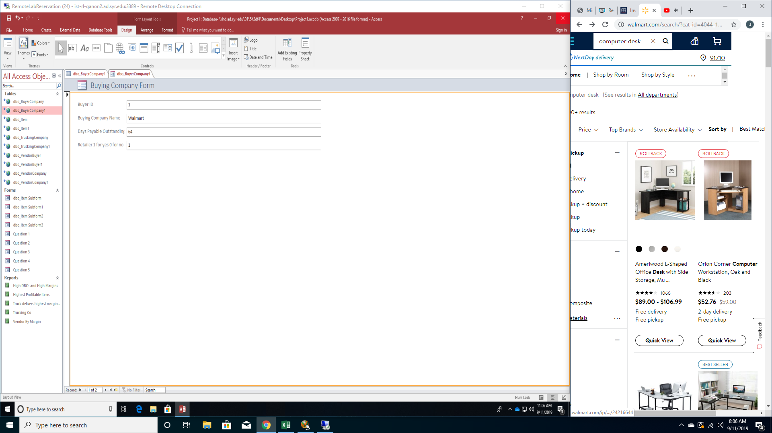

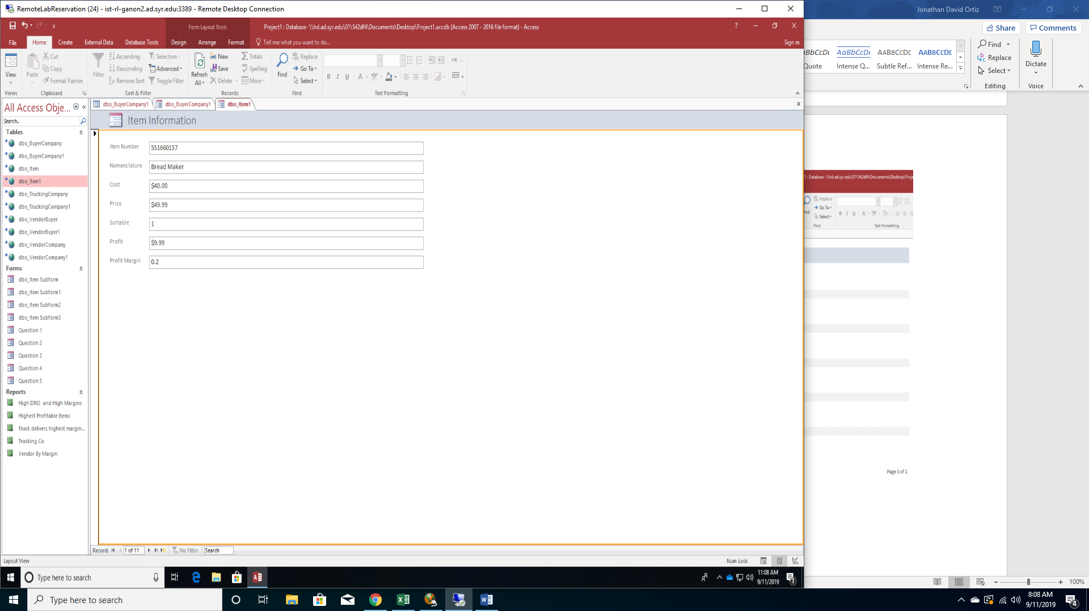

**Data Questions:**

--Which Vendors with the highest Days Receivables outstanding have the highest profit margin products?

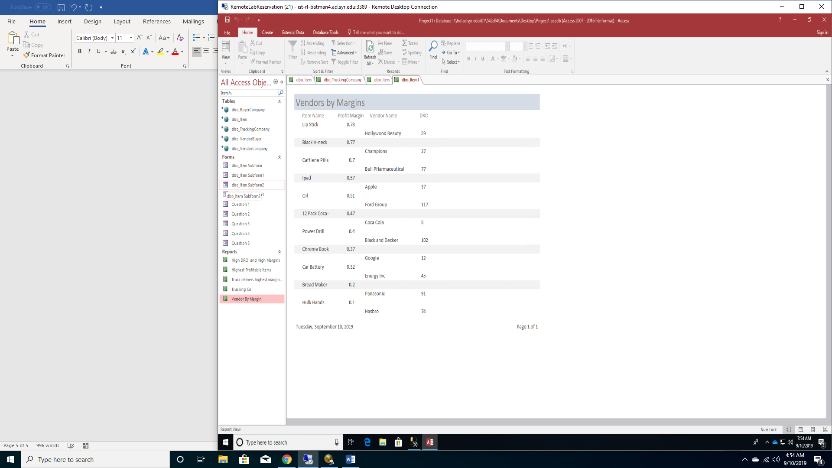

--Which Trucking Companies with the most cash are transporting the highest profit margin products?

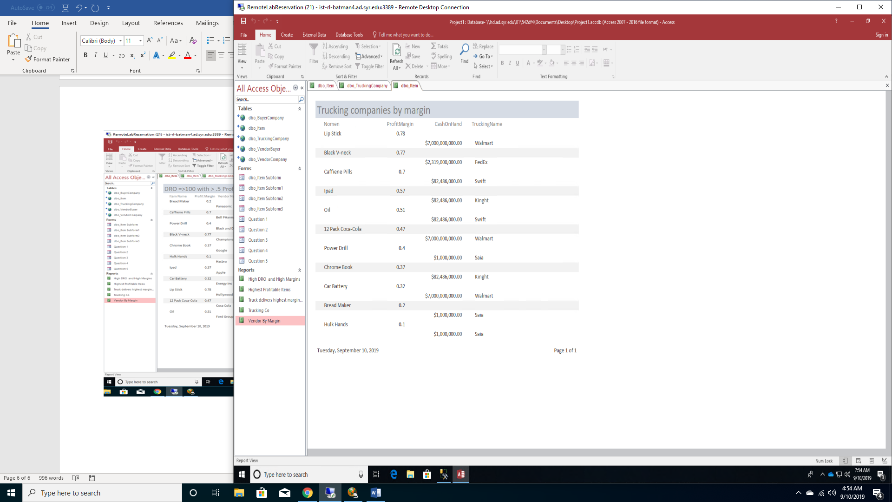

--Which sortable products have a higher than 10% profit margin?

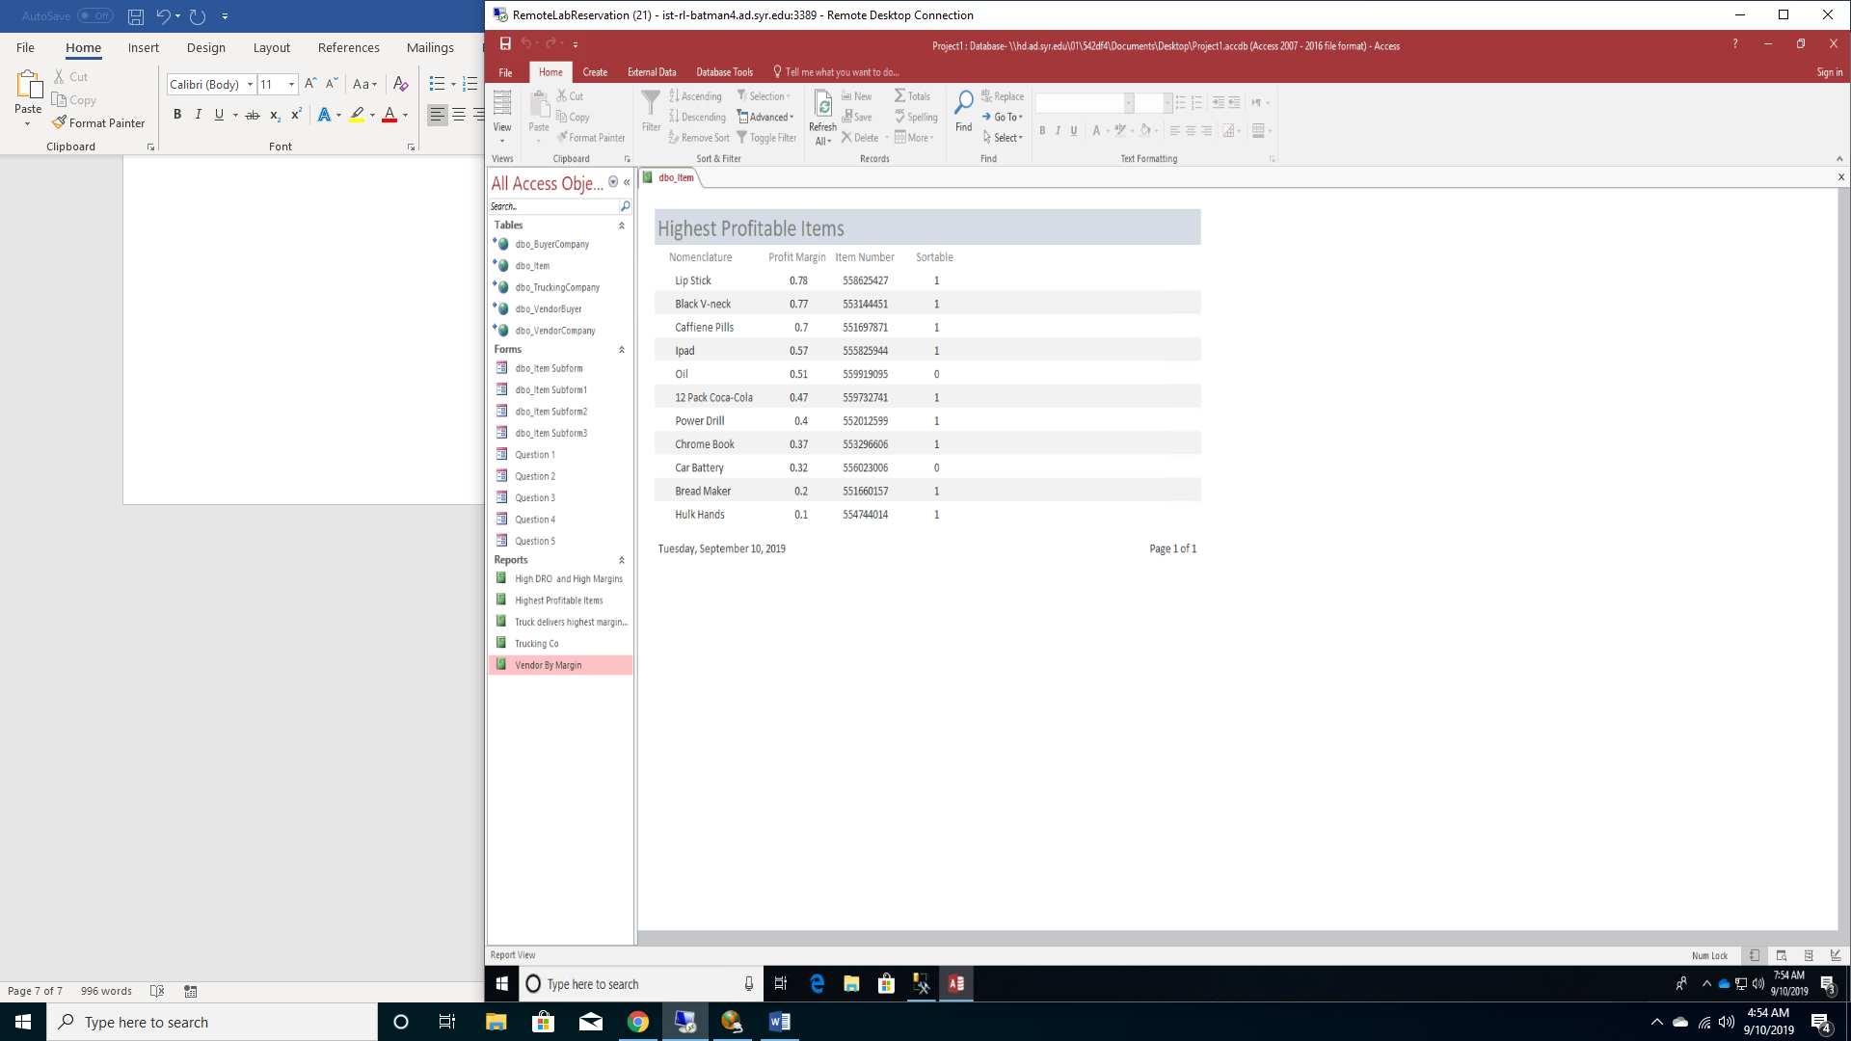

--Are there Products with higher than 50% profit margin being sold by vendors with over 100 days receivable outstanding?

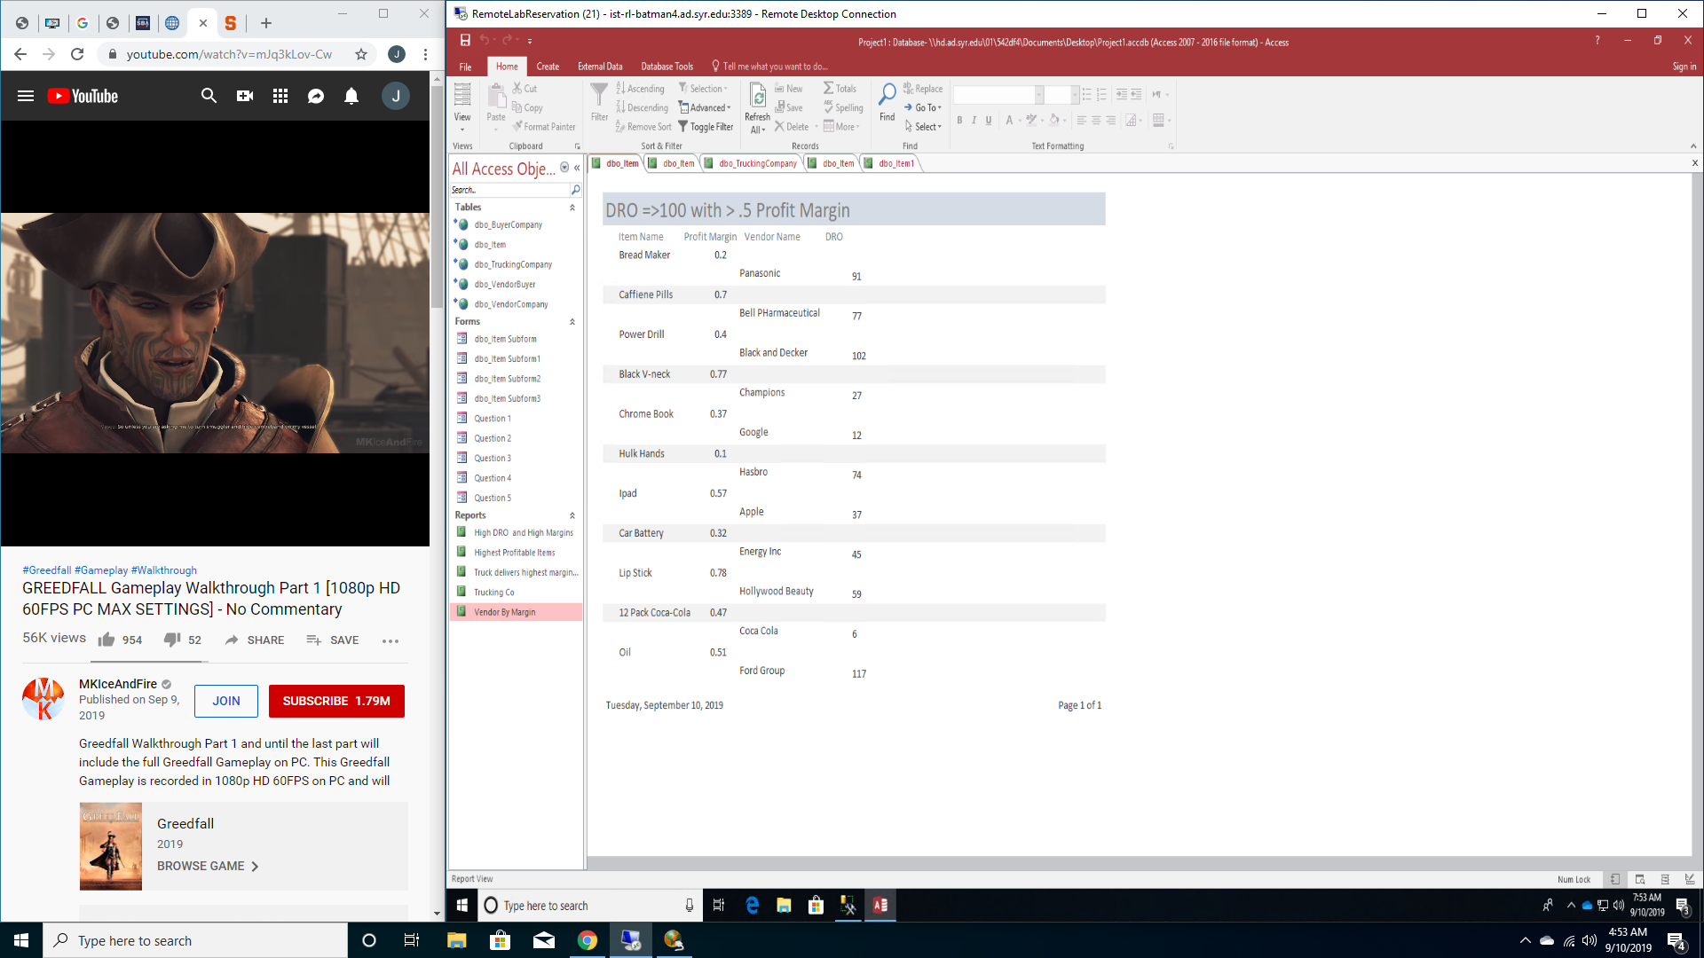

--Which Trucking company is delivering the highest margin items?

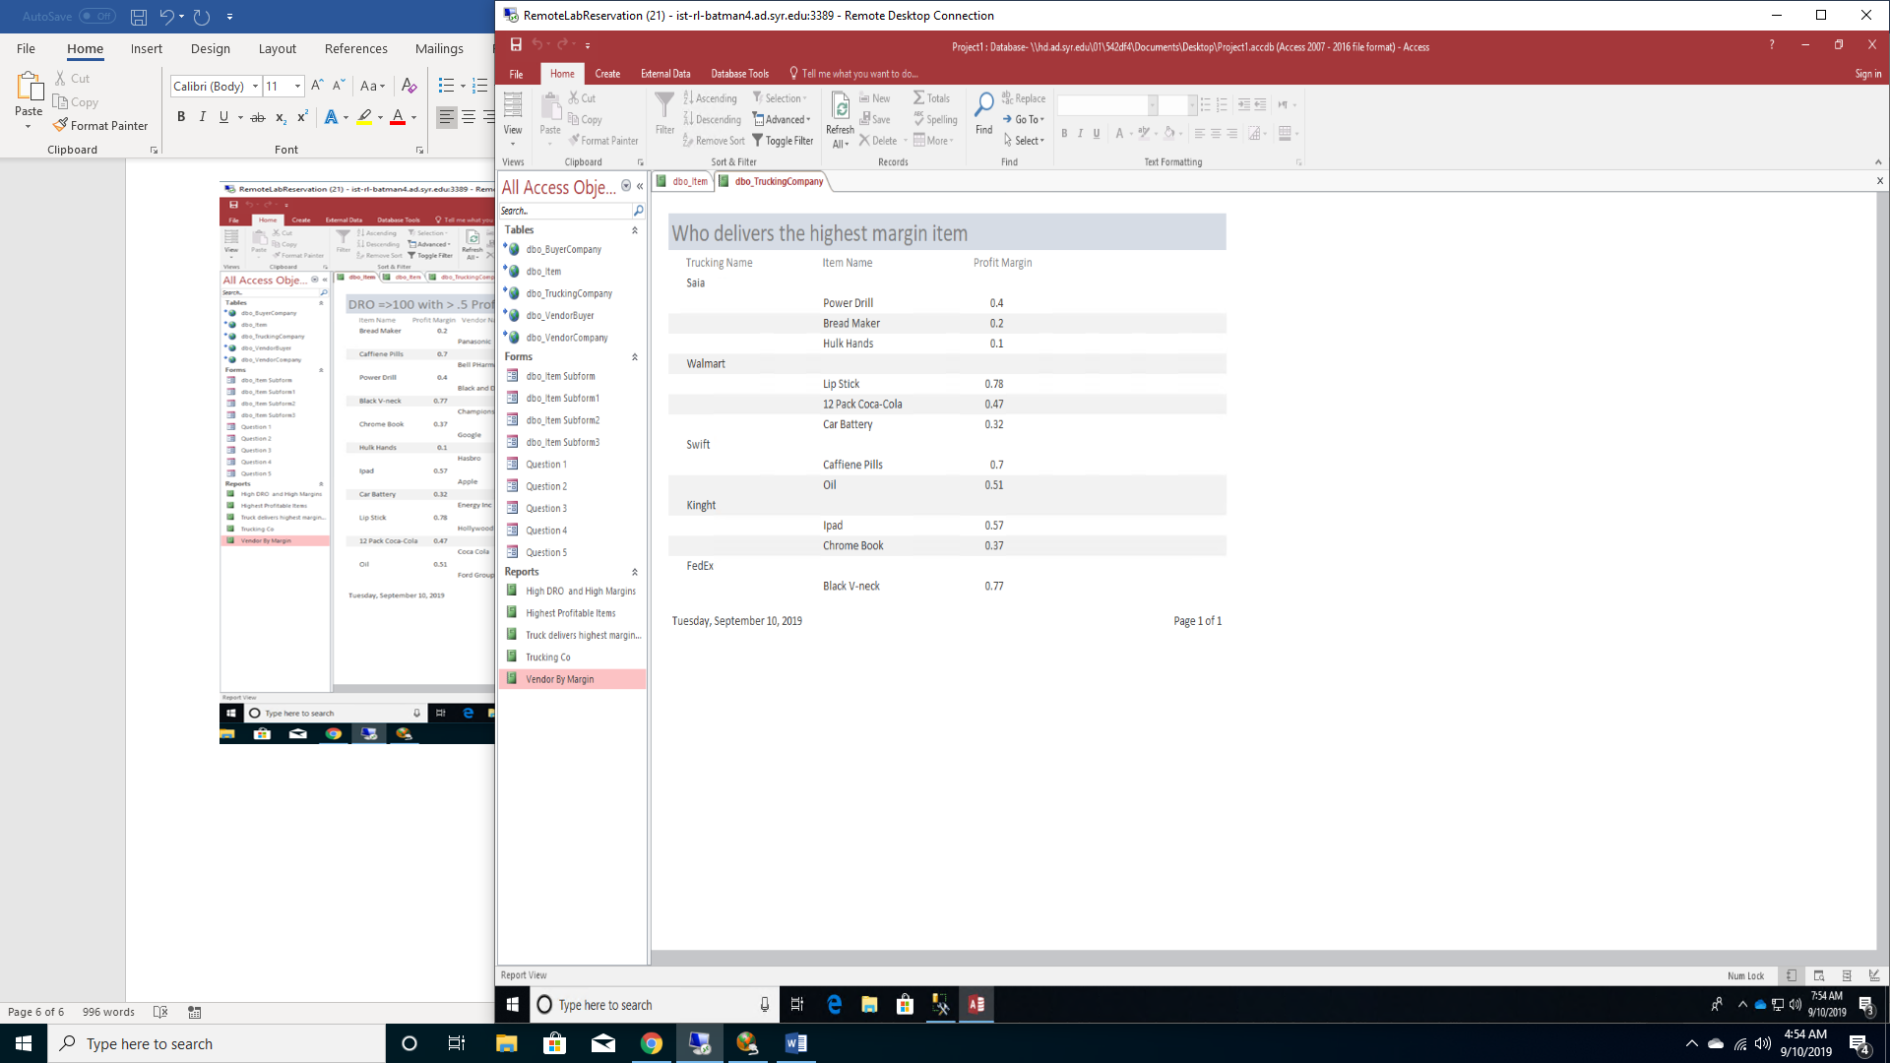

**Reflection**

To conclude, provide a brief reflection on the process. Some questions to ponder:

• What assumptions did you have at the start of your project that changed by the end? Think in terms of both your own problem domain as well as your knowledge of the process.

At the start of my project I believed I would be able to get all the data to answer my original questions, however that was a wrong assumption, even as the inbound manager I could not get all the data straight from my company, so I had to get it from public areas. I also assumed my model would not change at all and worked ahead and was stumped for a while until the later weeks.

• The next time you do this, what will be different?

I will see all the data I have available before I develop my questions. I will also start to think about making it more user friendly. The next time will probably consist of a lot more data from excel file, which will at least make data collection easier. However, inserting it all will be much more time consuming.

• Regardless of whether you go through these steps again, how do you think it will inform your approach to data as an information professional?

It has really changed my outlook on how much thoughts goes into being a database administrator and creator. I didn’t realize the process and its complexities. I will have a better plan, especially with a better understanding having completed a mini database.

**Summary**

Although it did not come easy, I got what I was looking for in this project. I answered my data questions and learned to build a database. Things did change from week 1. I had to change my meta data from the original ERD model. I also had to change my data questions because sadly I did not get all the data I wanted to. My data came from multiple sources. Walmart.com and Jet.com gave me most of my data. I did get permission from my job to learn the trucks that were the couriers of the items I had. All data is made up even though it may be real.

I really prefer keeping everything in SQL and retrieving my information through there. I am more comfortable with SQL and using select functions than using access. I also believe data manipulation is better in SQL.

In conclusion, my data questions have made me realize what industry my business plan would work best for and it is make-up. The Profit Margins are incredible, the items are small, and the companies have high outstanding receivable notes.